Batting:

1 – Batting Stance

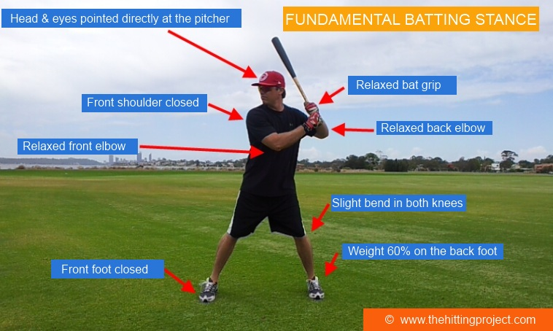
KEY POINTS
- Hands as close to the hitting position as possible. The closer your hands are to the hitting position the less chance there is for error.
- Feet should be straight or slightly inward, and are spread approximately shoulder width apart. The wider the batting stance the less chance a hitter has at lunging out at the baseball. If a hitter lunges out at the baseball, it becomes very difficult to generate any power or consistency with a baseball swing.
- Weight is even or shifted slightly to the back leg (there should be between 50% & 60% weight shift to the back leg). Once again, this helps to prevent a hitter from lunging out at the baseball.
- The lower half is in an athletic stance (like the hitter is going to tackle someone). This gives a hitter balance in the batter's box, maintaining balance is key for hitting off speed pitches and helps to prevent a hitter from falling over on the follow through.
- The head and eyes pointing straight at the pitcher, this gives the hitter the best chance of seeing the baseball out of the pitcher's hand. The sooner a hitter spots the baseball out of the pitcher's hand, the longer he has to react to the pitch type & to hit the baseball.
- Straight up and down with the upper body or tilted slightly from the waist. Too much tilt from the waist can make it more difficult to get both eyes pointing at the baseball. It is vital that the hitter maintains eye contact with both eyes to give himself the best chance of seeing the baseball as soon as it leaves the pitcher's hand.
- The should be no tension in the back or front elbow, tension in the back elbow will slow down a hitter's bat speed.
- Relaxed grip of the bat, the bat is gripped in the middle of the fingers and not the palm of the hand. A loose grip assists in keeping the entire upper body relaxed. This can be related to a boxer's punch, the more a boxer tenses up the less powerful his punch is. The more a hitter tenses up, the slower his swing will be.
2. Load
KEY POINTS FOR THE LOADING PHASE OF A BASEBALL SWING
The purpose of the load is to get the hitter in the "foot down position" before the baseball reaches the bottom third of its travel to the plate.
- Ideally the load should be as short as possible.
- The load should begin as early as possible -- better to early than too late.
- The load should be fluent and have rhythm.
- The trigger point for a hitter's load will vary depending on the pitcher's speed to the plate -- meaning, how fast the pitcher's delivery is when he's in the wind up and set position.
- The trigger point for a hitter's load can also vary depending on the type of pitch a hitter is looking for -- the hitter may load a bit more when he is sitting on a fastball. However, if a pitcher has a good change up, then the hitters load may have to be shorter so he does not get fooled by lunging at the pitch.
- When a hitter is "in the hitting zone" the load will come naturally via locking in on the pitcher's release point.
- The aim of the load is to get the front foot down and into the foot down position just before the ball reaches the bottom 1/3 of the hitting zone.
WHEN TO START TO LOAD AS A HITTER As with all types of load and timing devices the point when a hitter initiates the load will vary from pitcher to pitcher, depending on the pitcher’s delivery type and velocity. The perfect time for a hitter to figure out when to initiate the load phase of a swing is in the on deck circle, where the hitter can time his load to the pitcher's delivery. Typically a hitter will begin his load as the pitcher releases his hands out of his glove, some hitters start their load as soon as the pitcher picks up his knee or when they see the ball just before it is release

3. The Stride
HITTING STRIDE BASICS
KEEP THE STRIDE SHORT
The hitting stride should be as short as possible. The bigger a hitter’s stride, the more chance he has for error. When a hitter keeps the stride short, he gives himself more chance of having a consistent swing over the course of a baseball season.
KEEP THE STRIDE SOFT
This is where the old “step on an eggshell” saying comes into play. When a hitter strides he can imagine that he is stepping on an egg shell that he does not want to crush. Otherwise, a hitter that has a long/hard stride will cause unwanted movement with the head and eyes, and you can’t hit what you can’t see.
SIMPLE HITTING MODULES
Find out how to teach any kid to hit a baseball in 5 simple steps: Learn more...
NOT TOO EARLY NOT TOO LATE
A well known hitting stride philosophy is, "get the front foot down, not too early or not too late". As a hitter strides or steps during a baseball swing, the front foot needs to be planted softly to the ground a split second before the ball arrives, in order to gain the most out of the swings natural momentum. If a hitter has his front foot down too early, his body loses its momentum. Alternatively, if a hitter gets the front foot down too late then a he will be late on the fastball, which will result in a foul ball or a swing and a miss.
LAND WITH THE FRONT FOOT CLOSED
The front foot, should land closed and not open up too early. Otherwise, if the front foot lands open then the hips, shoulders and head will fly open, and of course flying open causes major issues with a baseball swing. The front foot has a tendency to naturally open up after contact is made, this is fine as long as before contact the foot remains closed or at worse slightly open.

SELF EVALUATION
Self evaluation, is an important tool in understanding the correct hitting stride. A hitter, is able to analyze his front foot when he takes a pitch in a game or in batting practice. Once and a while, after taking a pitch a hitter can take a look at the front foot to ensure that it is closed and not open. If the hitter finds he is striding with the front foot open, this strongly indicates that he is rushing his swing.
Other causes of striding with the front foot open include:
- Not seeing the baseball out of the pitcher's hand
- Lack of confidence/self-belief that a hitter can handle any type of pitch that comes his way
- Trying to pull the baseball
- Trying to hit the baseball too hard

4. Locked In
WHAT IS THE LOCKED IN POSITION
The Locked In Position is stage 4 in the 7 Stage hitting cycle. Locked In Position (or foot down position) is a common area that all hitters should end up in, before they begin forward hand movement to the baseball. Locked In Position comes directly after the load and stride phases of the swing and is where the hitter makes his final decision on whether to 100% commit to his baseball swing.
SIMPLE HITTING MODULES
Find out how to teach any kid to hit a baseball in 5 simple steps: Learn more...
CHARACTERISTICS OF THE LOCKED IN POSITION
- Front shoulder is locked under the chin
- Head and eyes are locked on the baseball
- Front foot has landed and is closed
- Hands have separated from the body
- Weight has shifted to center or 50/50
- The hitter is making his final decision on whether to swing at the baseball
THE POINT OF NO RETURN POSITION
The THE POINT OF NO RETURN POSITION is the very last possible moment the hitter can hold up his swing and take the pitch. The hitter can do this by pressing his elbow hard into his body, but not progressing forward with his hands. Once the hands go forward it is very hard to stop the swing and there is a very good chance the umpire will call a check swing.
A good hitter will be able to hold up in THE POINT OF NO RETURN POSITION when he sees something he does not like about the pitch at the very last second. For example, a pitcher may have thrown a late breaking split finger fastball, in this case the hitter may only see the rotation at the very last moment and holds off on his swing just before THE POINT OF NO RETURN POSITION.
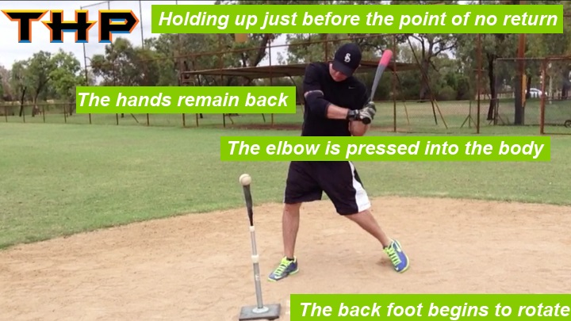

5. Swing Path
WHAT CAUSES BAT DRAG OR SLOW BAT SPEED?
FLYING OPEN
Flying open with either the front foot, hips, shoulder or head will cause a hitter’s bat to drag through the zone. Flying open results in dropping the back shoulder, hands and bat head.
DIPPING TOO MUCH WITH THE BACK SHOULDER
As stated earlier, flying open causes a hitter to drop/dip the back shoulder. Dropping with the back shoulder is the number one cause of a long swing. Once the bat head drops beyond the point of no return, there is little chance of catching up to a good fastball.
TIGHT GRIP ON THE BAT
Tight grip causes tension in the forearms that results in a long swing with bat drag. There is nothing worse than watching a hitter tense up on the bat so much that he looks like Frankenstein when he swings. Loose grip equals a fast/tension free swing.
TENSION IN THE ARMS & ELBOWS
Besides the hands, the next worse spot to tense up is the arms and elbows. Tension in the arms will result in a long/slow swing. It is vital a hitter relieves all tension in the upper body while he presents in his batting stance. Refer to the image below.

